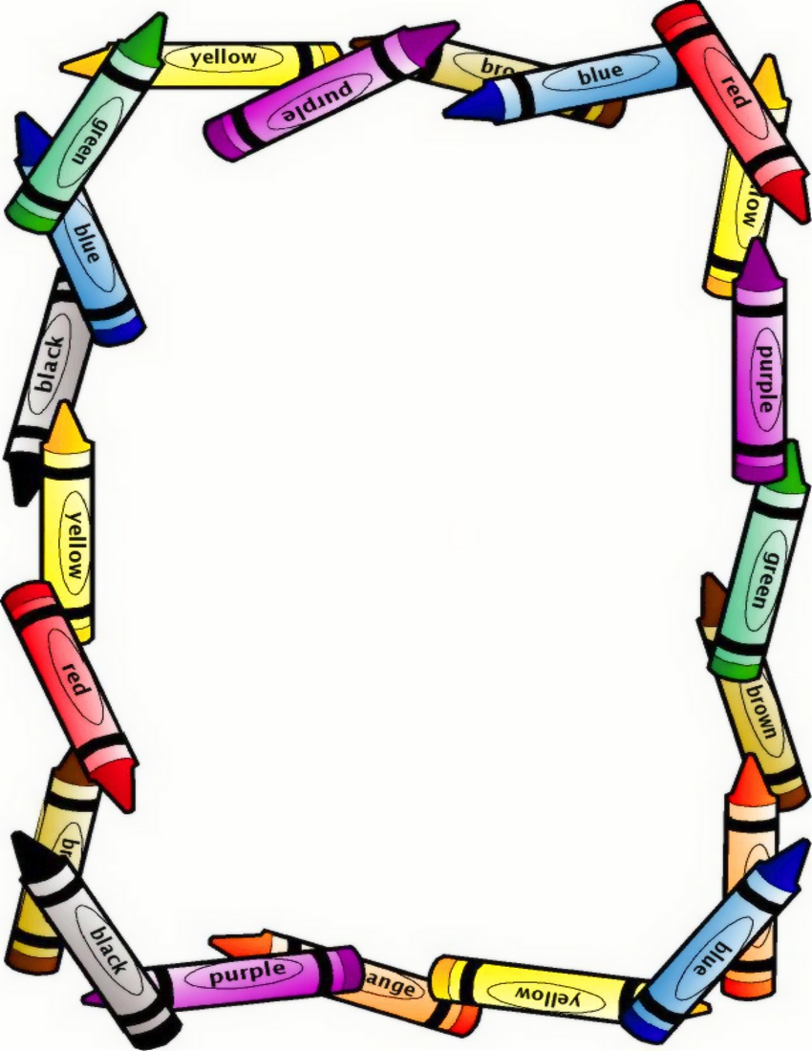

**HOME LEARNING PARENT & CHILD CHALLENGE**

**Pegging out the washing**

**Getting your child involved and giving them jobs to complete makes them feel important and clever building on their self-confidence.**

**Whilst pegging the washing out together use it as an opportunity to explore mathematics Talk about the shape and size of each item, which is biggest, count how many items there are, you could even hang them in order of size.**

**Teach them words and concepts like small, smallest, big, biggest long, thin, more, less, heavy, light and help them match numbers with quantity.**

**Using pegs is also great for building control in little fingers**

If you choose to accept the challenge please share your experience with us via a photo or comment in your child’s learning journey.

**Have Fun!**

If you choose to accept the challenge please share your experience with us via a photo or comments in your child’s learning journey.

**Have Fun!**