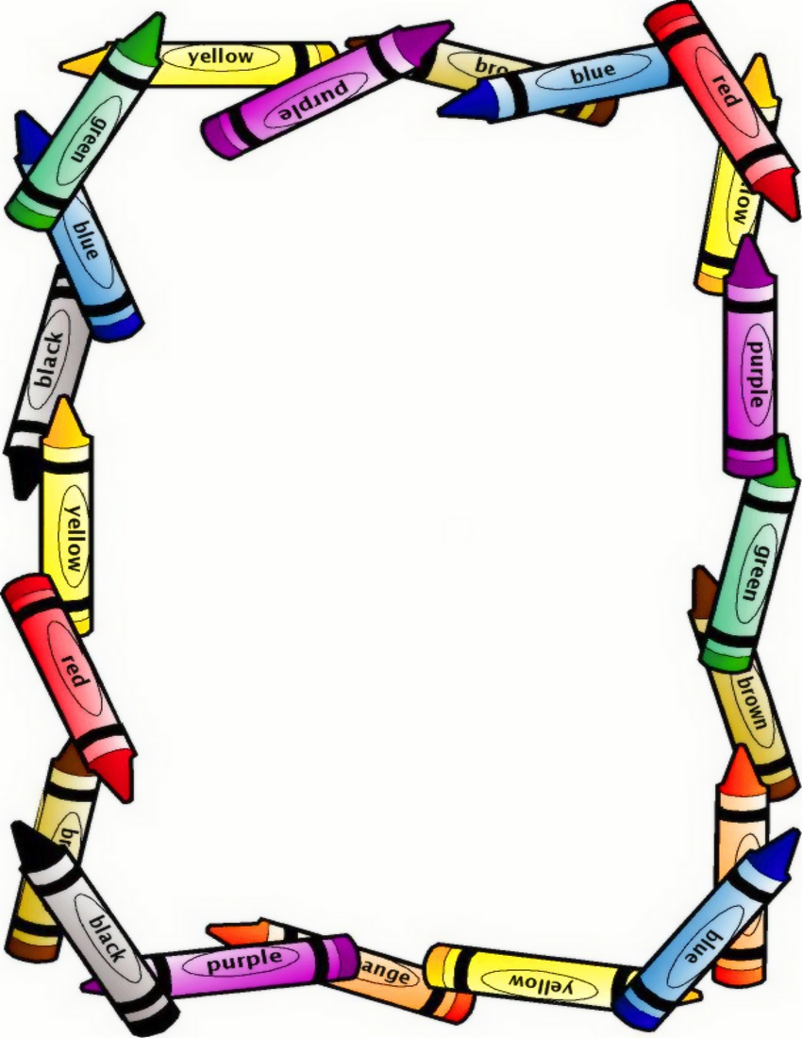

Make a healthy meal together-

Cooking with children is great for developing maths skills, fine motor skills, communication and language, understanding the world and learning about sequence.

Get your child to count, weigh, measure, mix, whisk, stir, chop (carefully), spread.

Talk about the smell, texture, taste and process asking lots of questions. Talk about the importance of healthy foods

And don’t forget to get them help wash up ☺

**HOME LEARNING PARENT & CHILD CHALLENGE**

**Staying healthy**

If you choose to accept the challenge please share your experience with us via a photo or comment in your child’s learning journey.

**Have Fun!**